Create the **IoT Hub** resource in the Azure Portal

<https://docs.microsoft.com/en-us/azure/iot-hub/iot-hub-create-through-portal>

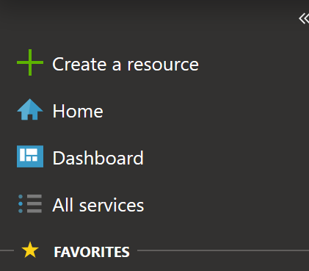

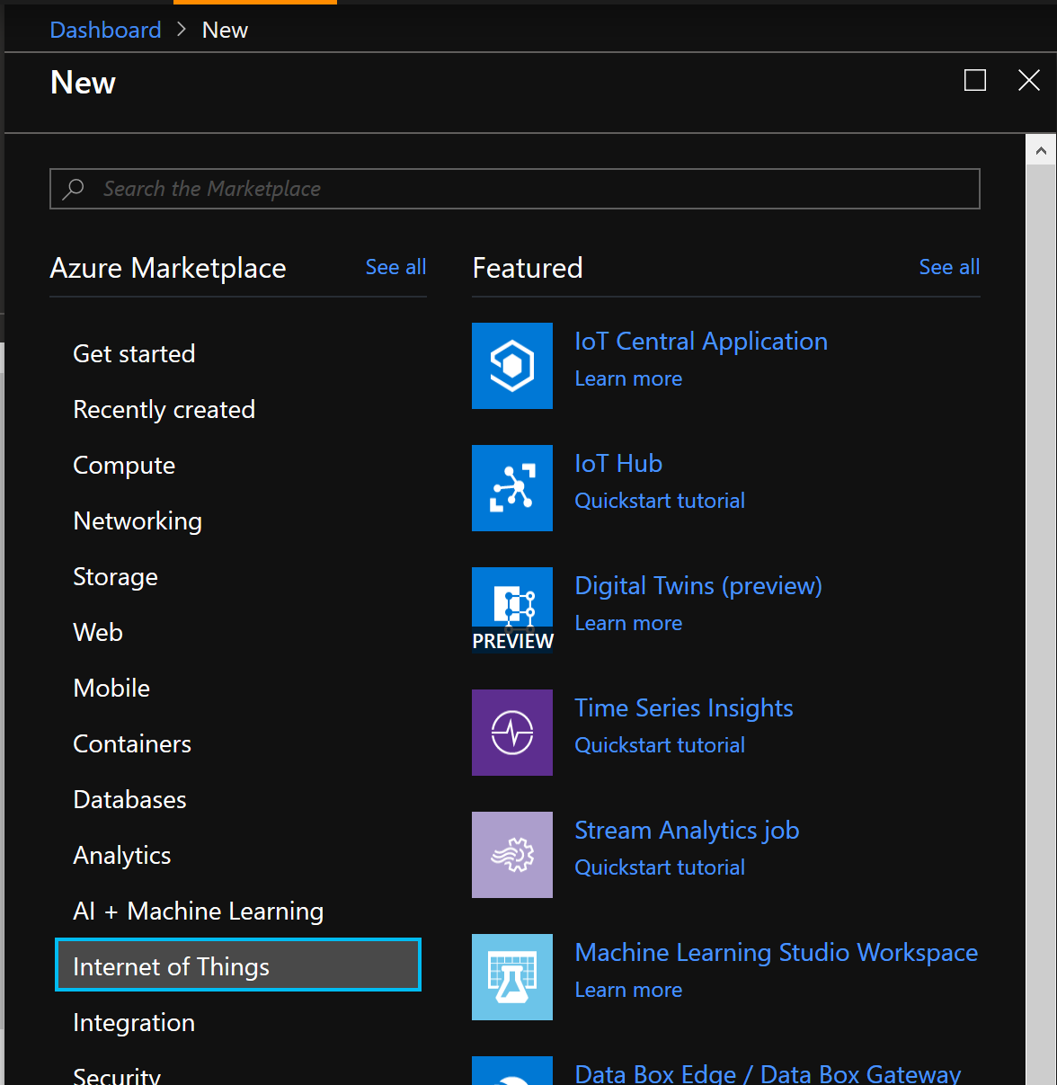

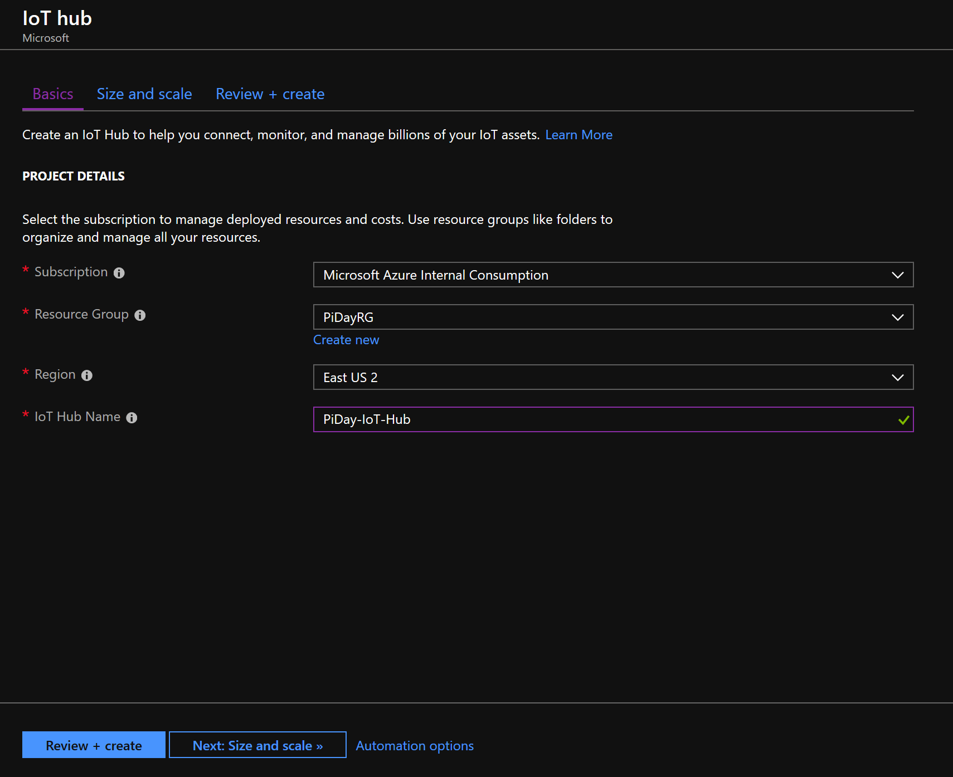

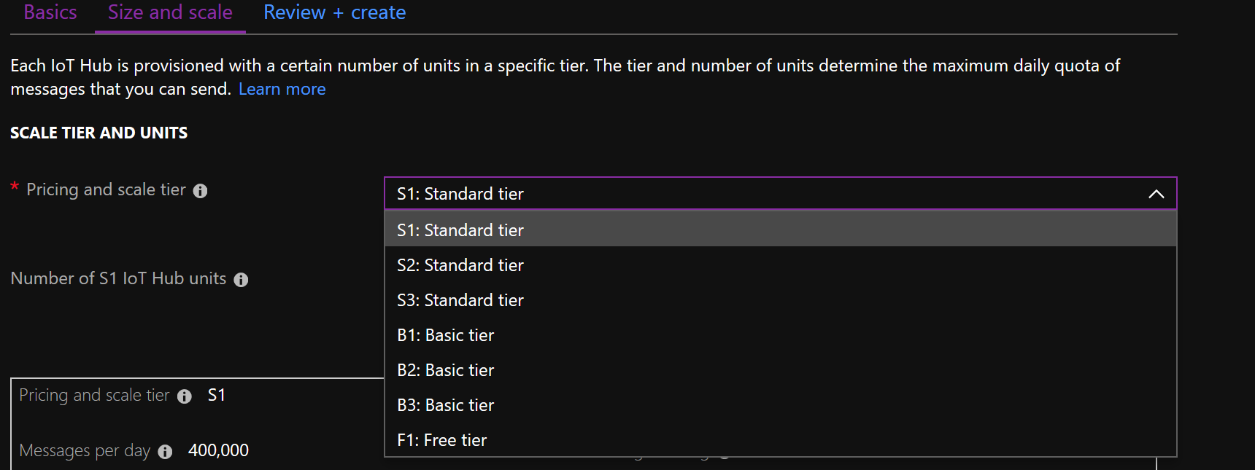

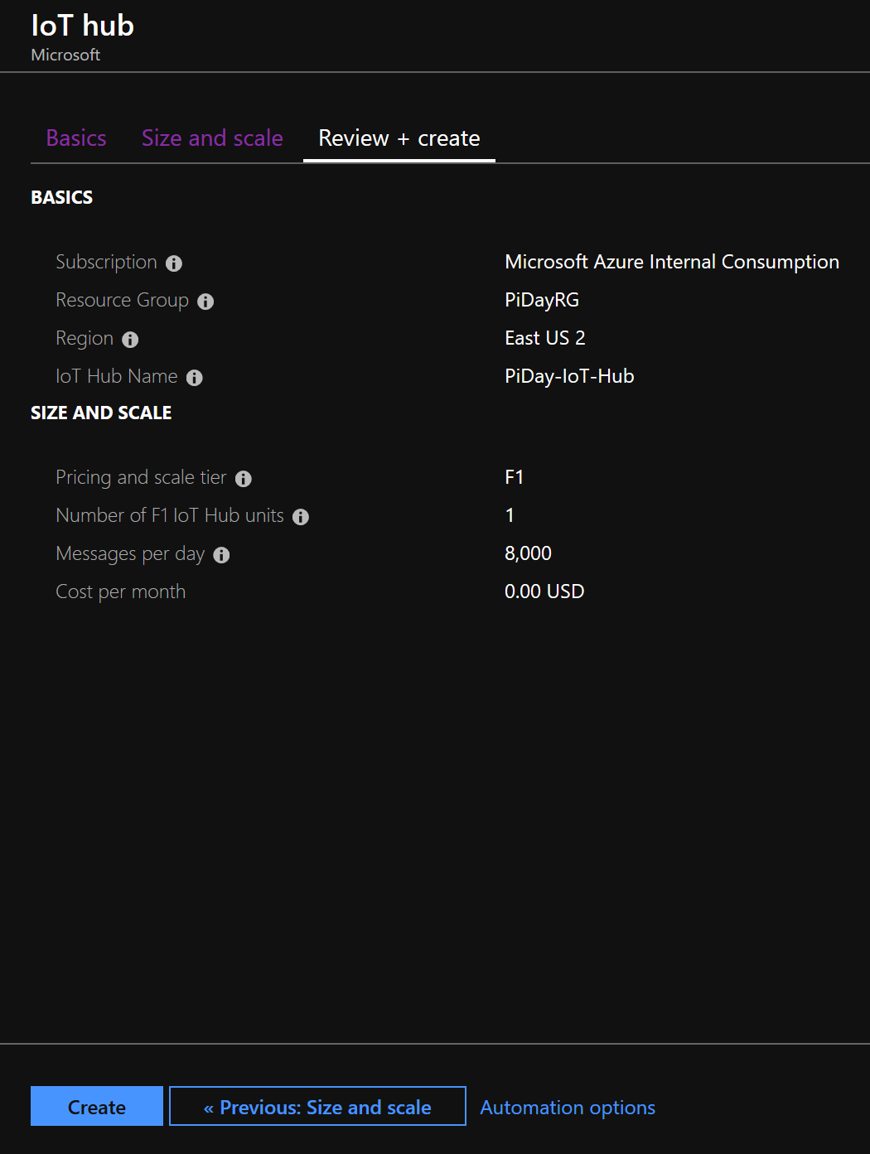

Create the **Event Hub** Namespace Resource

From the Azure Portal, create a resource

<https://docs.microsoft.com/en-us/azure/event-hubs/event-hubs-create>

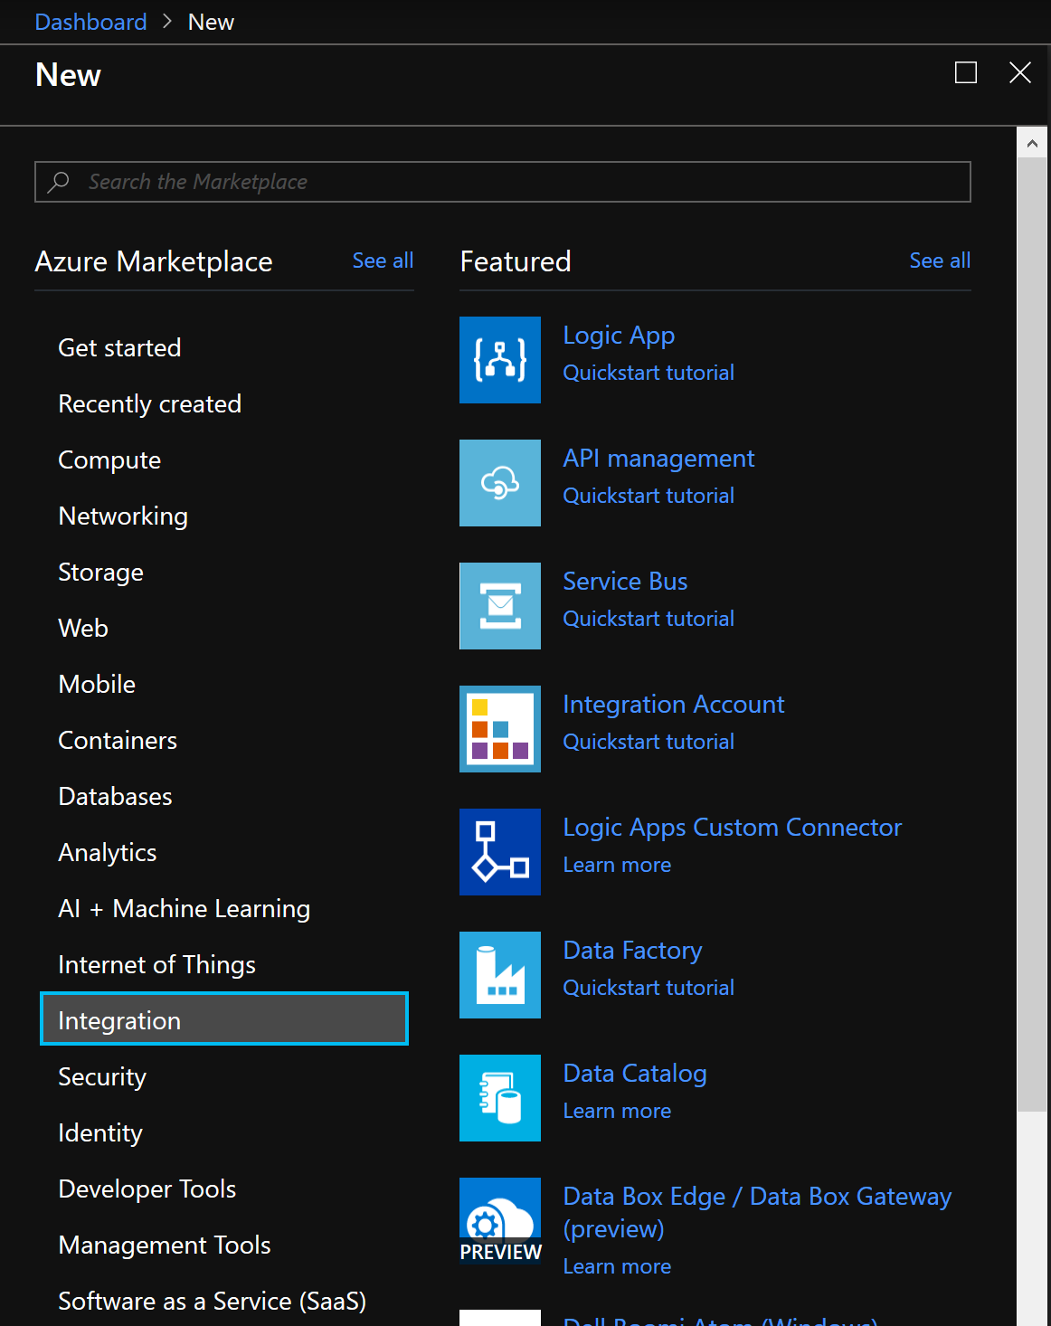

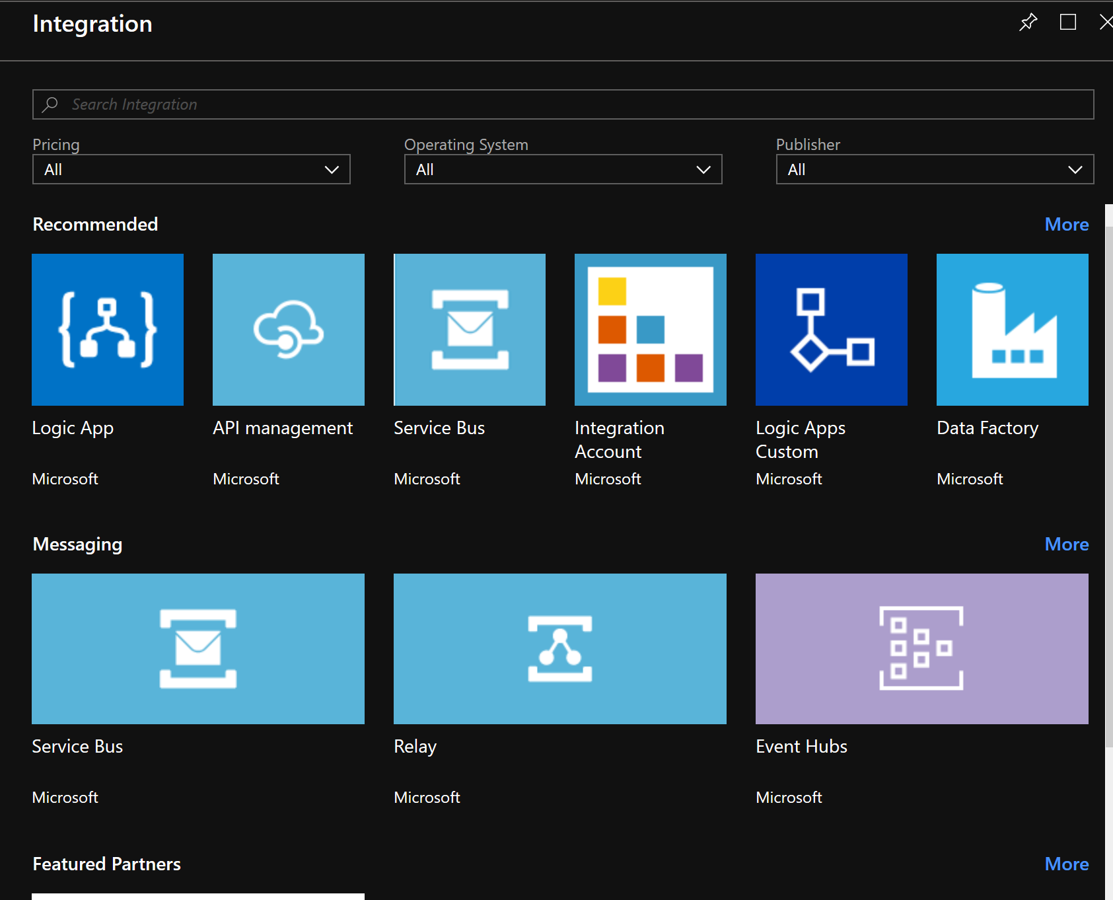

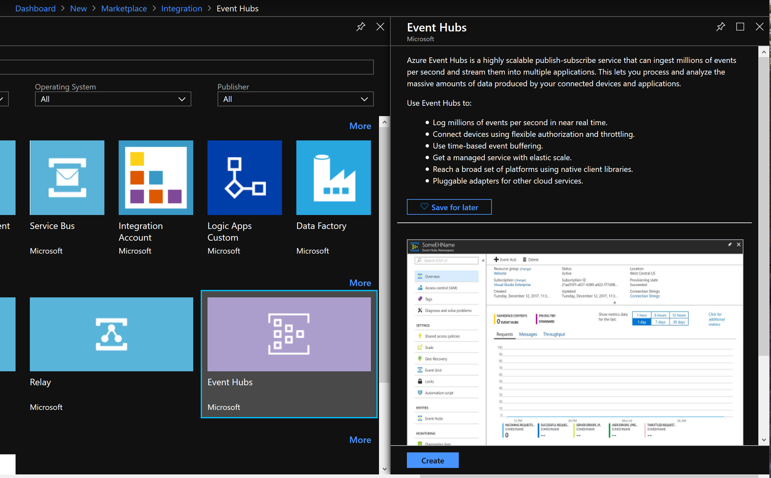

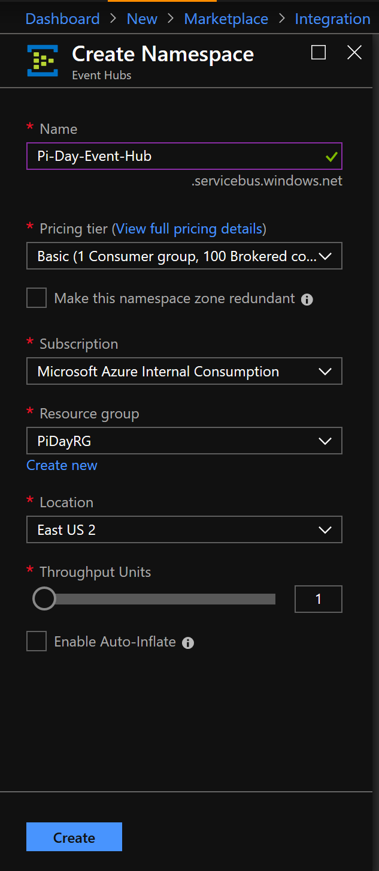

Create the **Event Hub** Instance

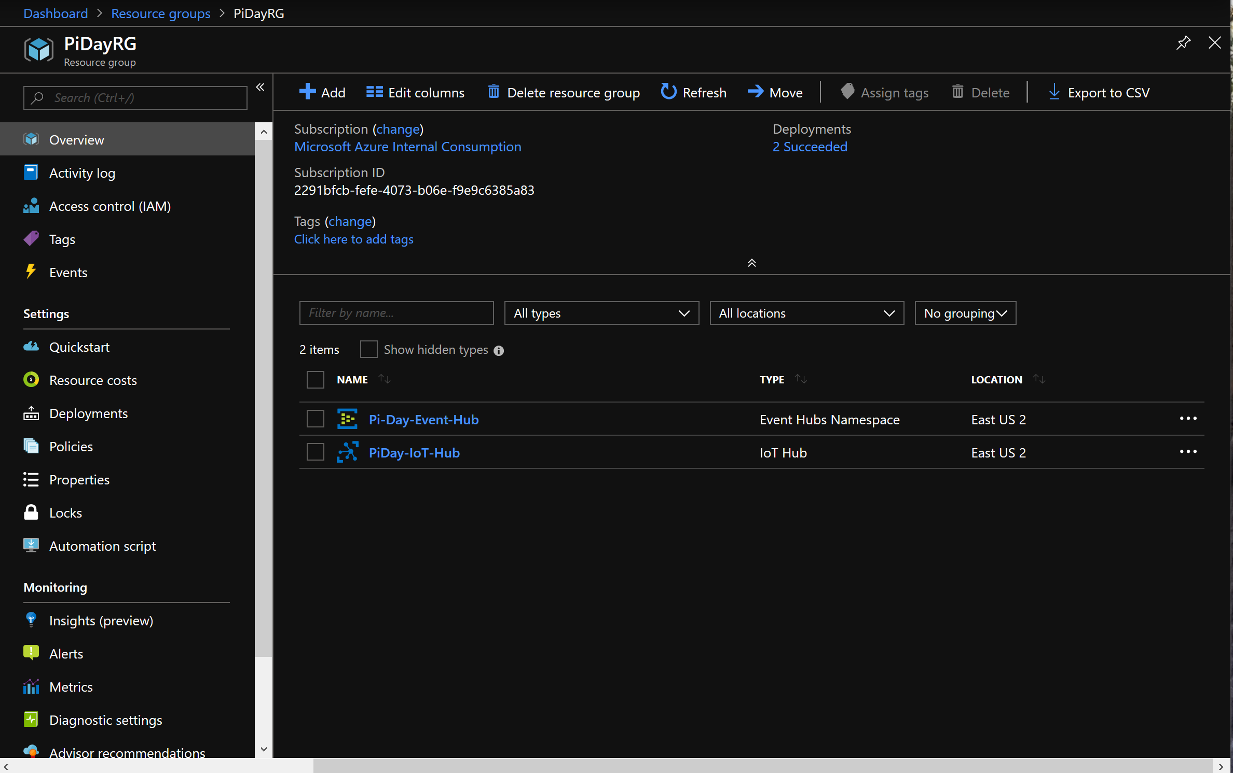

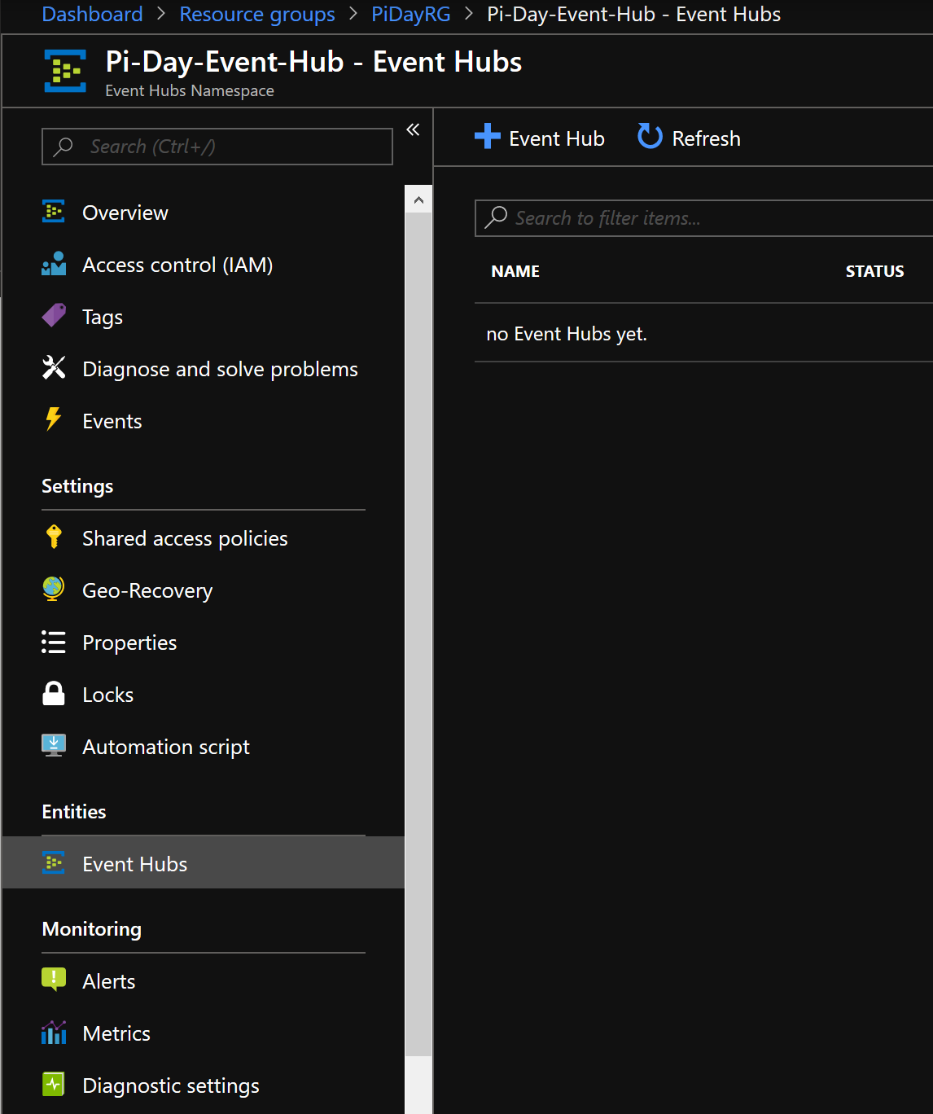

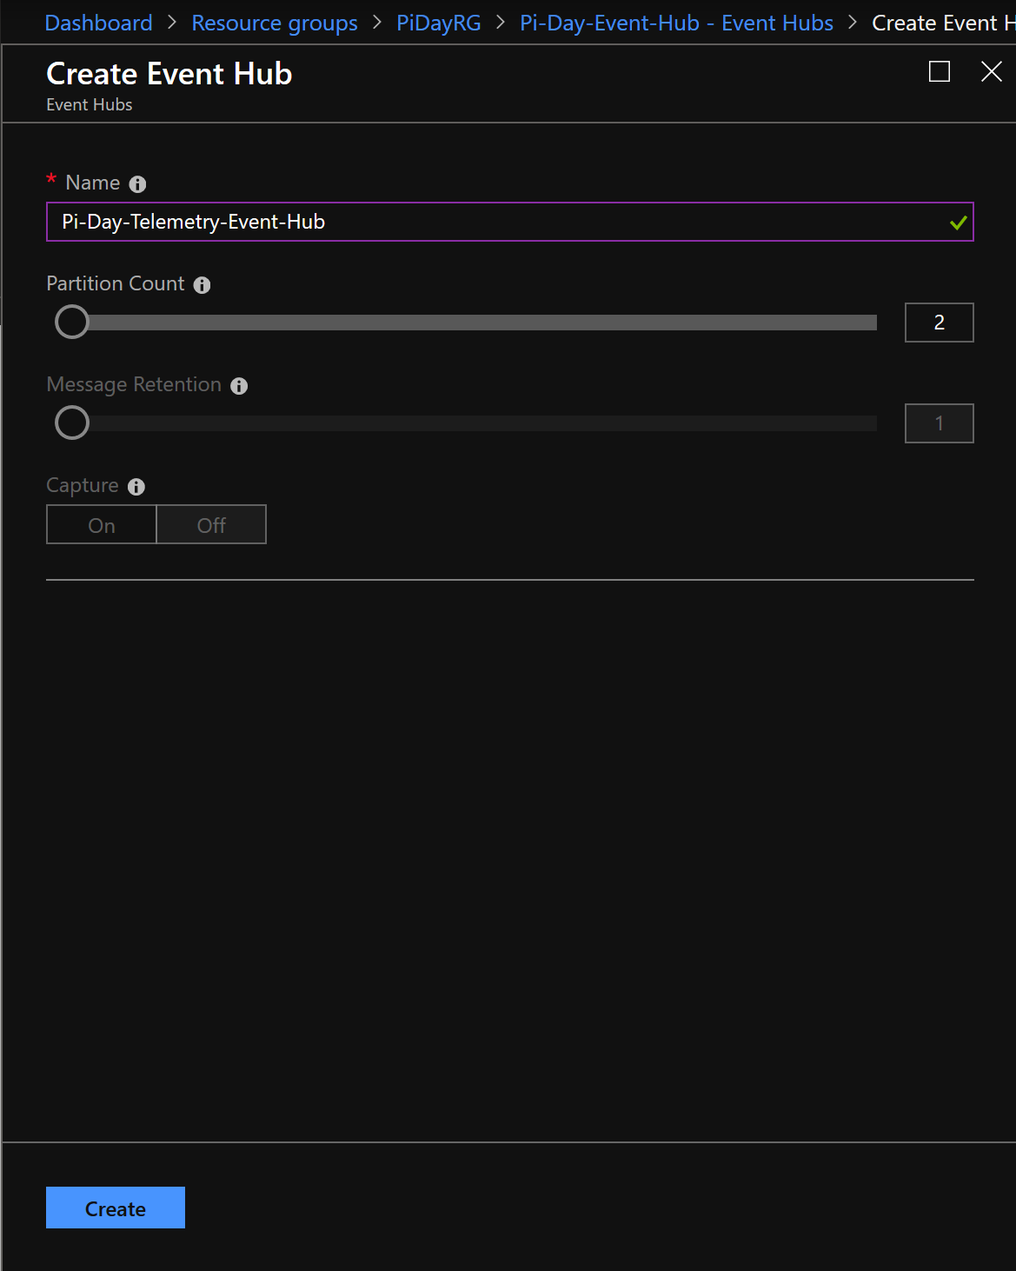

Create the **Function App** Resource

From the Azure Portal, create a resource

<https://docs.microsoft.com/en-us/azure/azure-functions/functions-create-function-app-portal>

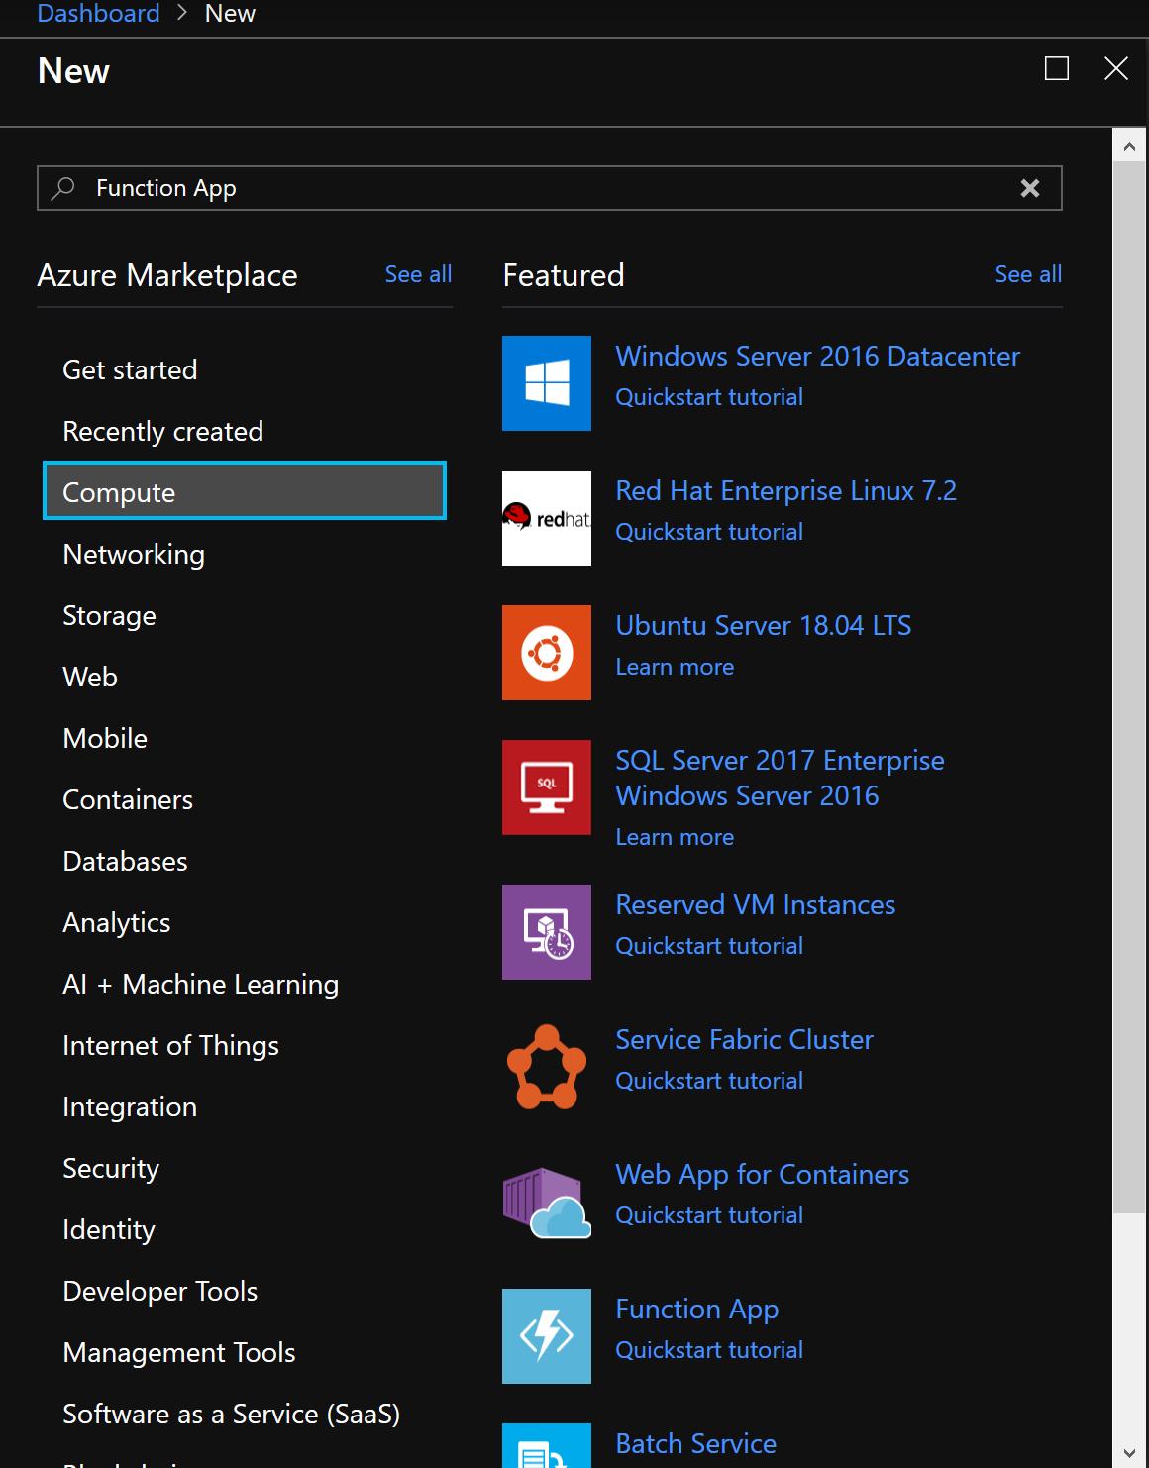

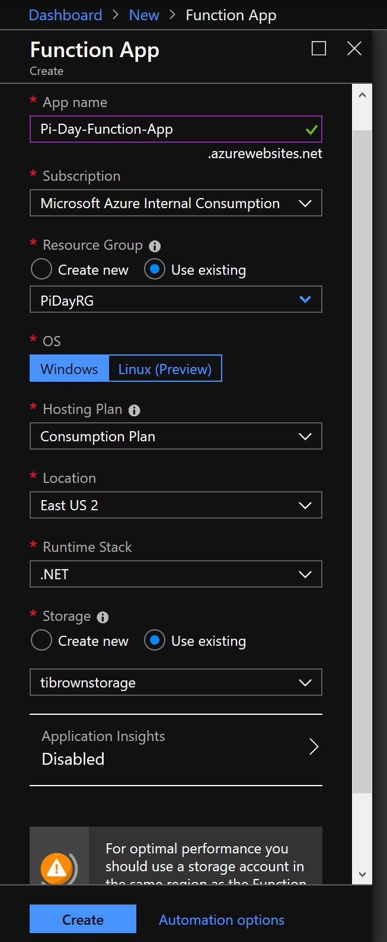

Create the **CosmosDB** Resource

From the Azure Portal, create a resource

<https://docs.microsoft.com/en-us/azure/cosmos-db/create-sql-api-dotnet#create-a-database-account>

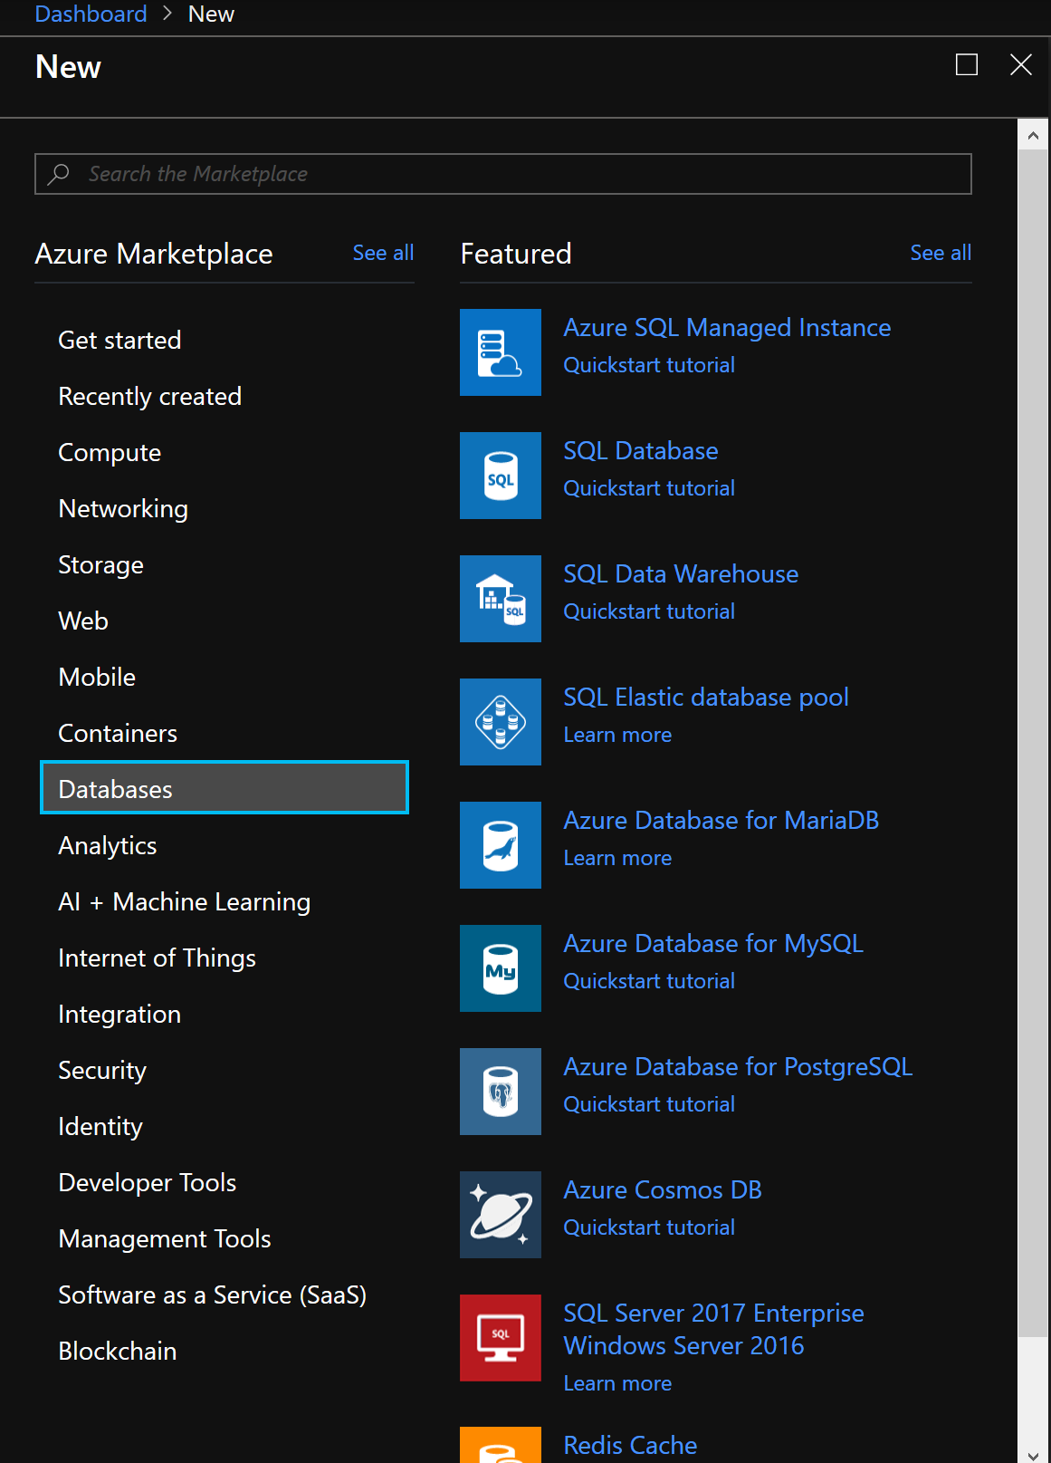

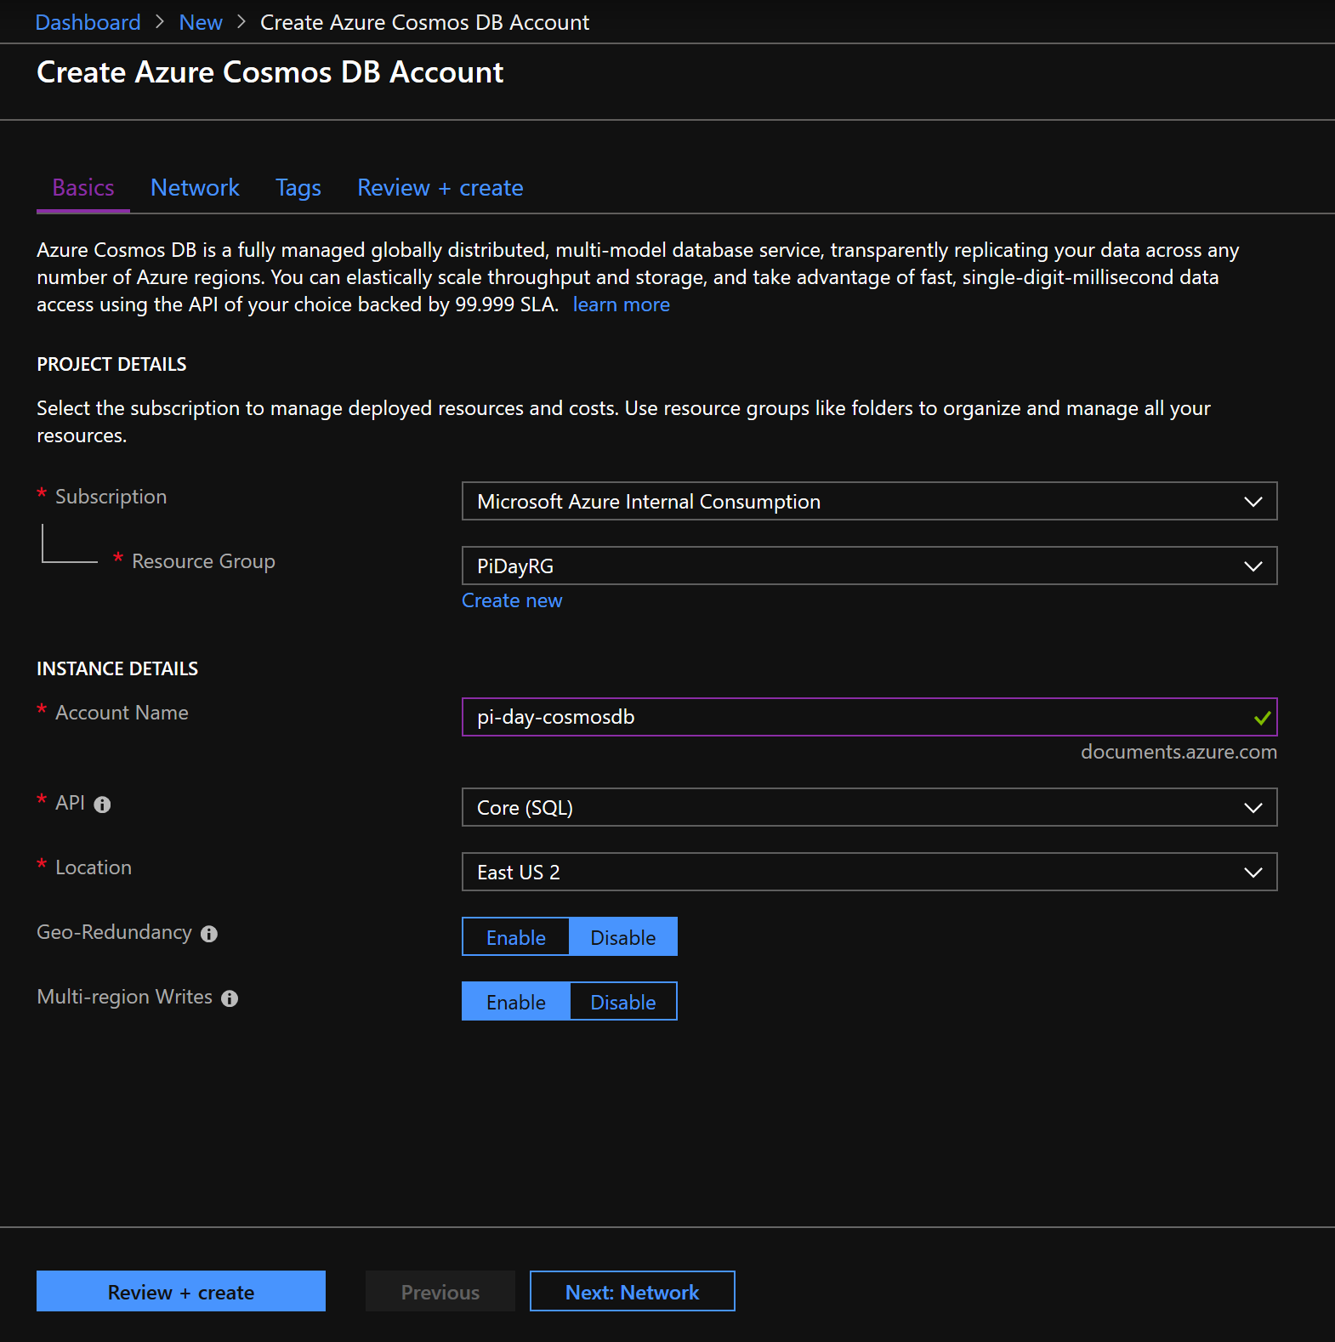

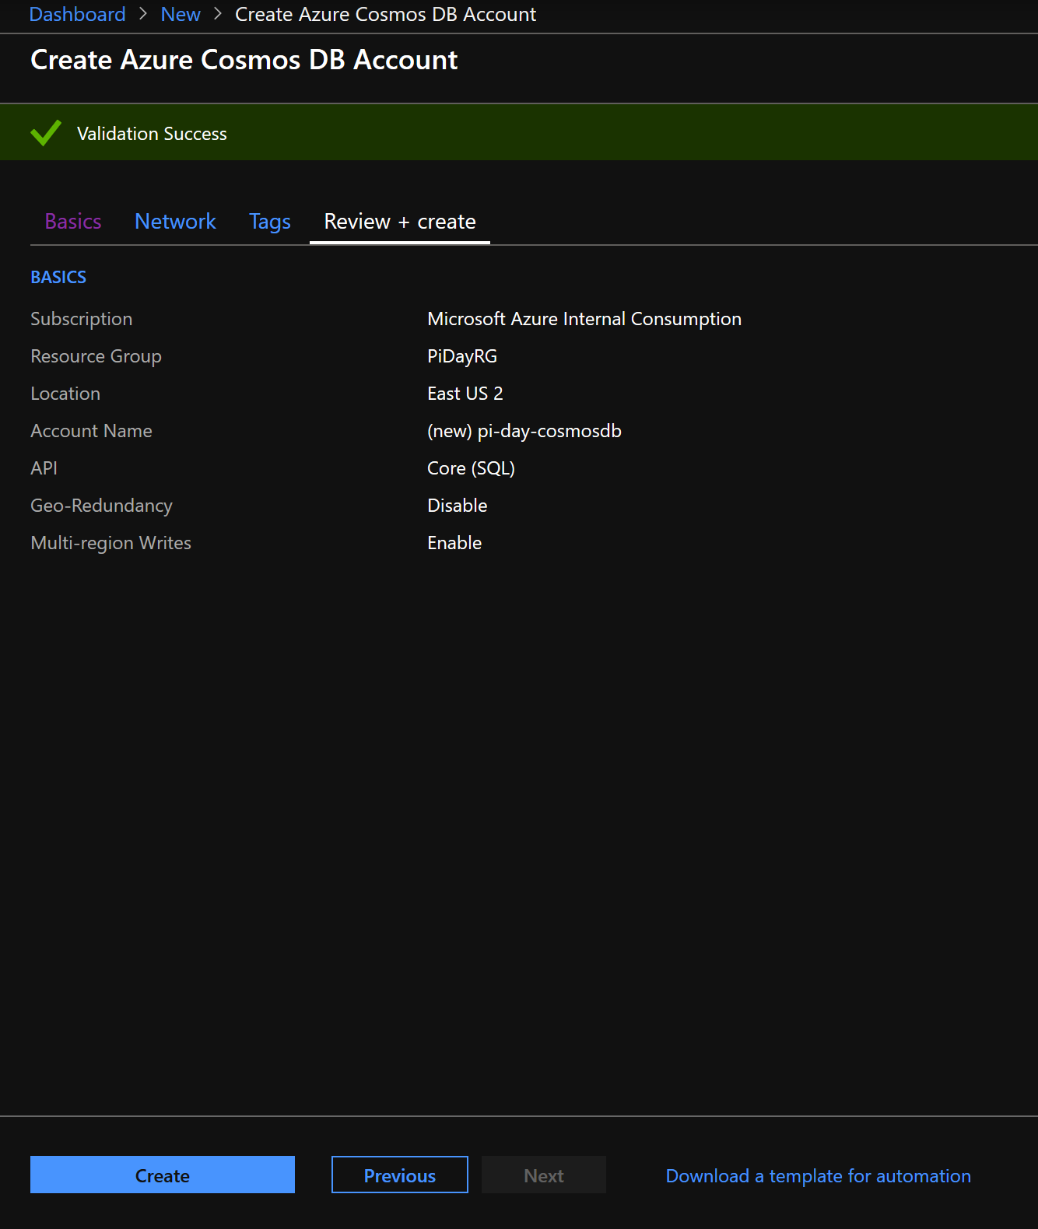

Create the **Azure Maps** Resource

From the Azure Portal, create a resource

<https://docs.microsoft.com/en-us/azure/cosmos-db/create-sql-api-dotnet#create-a-database-account>

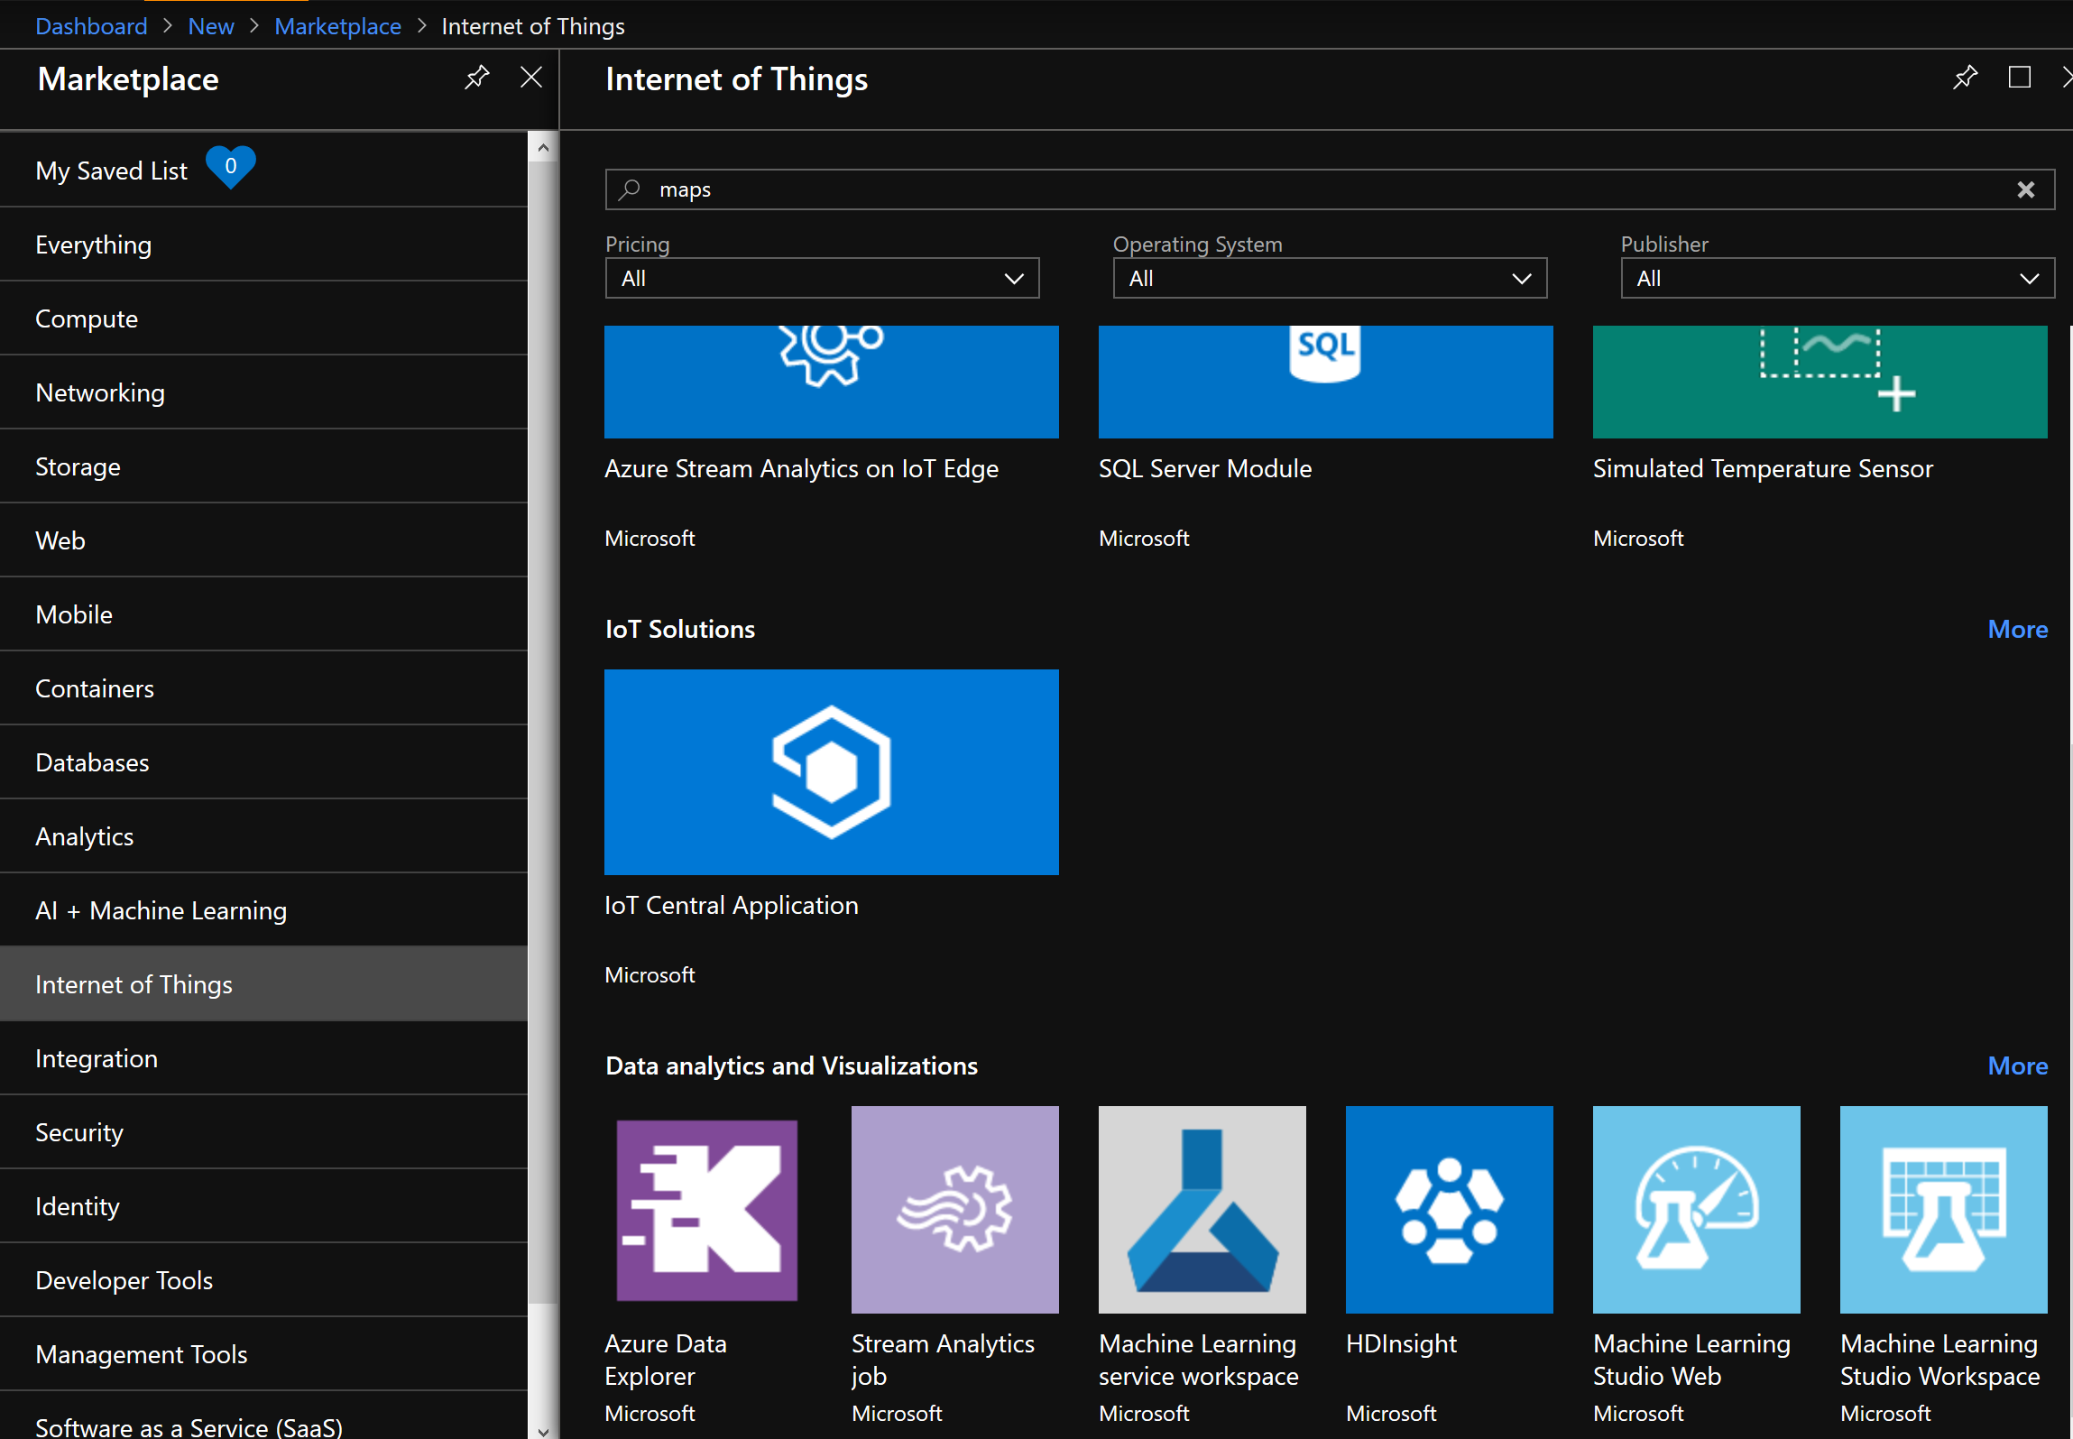

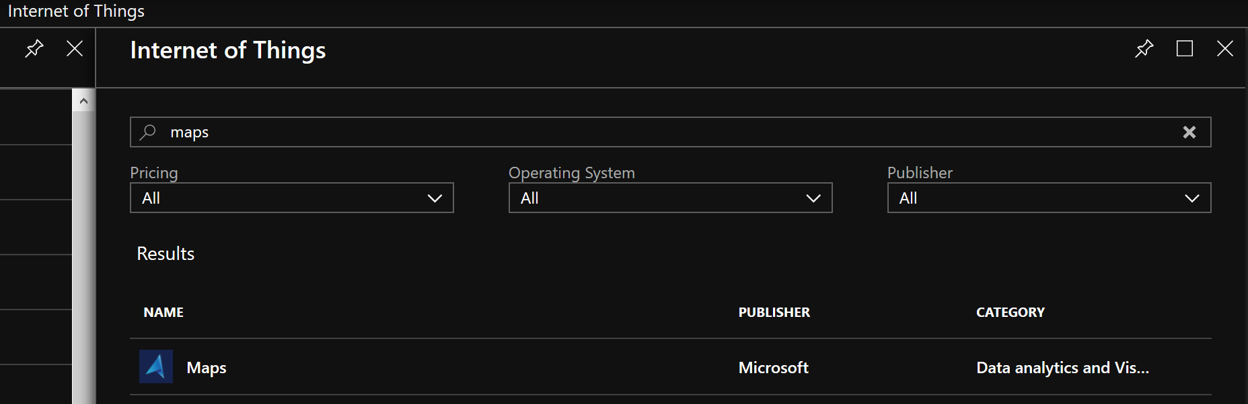

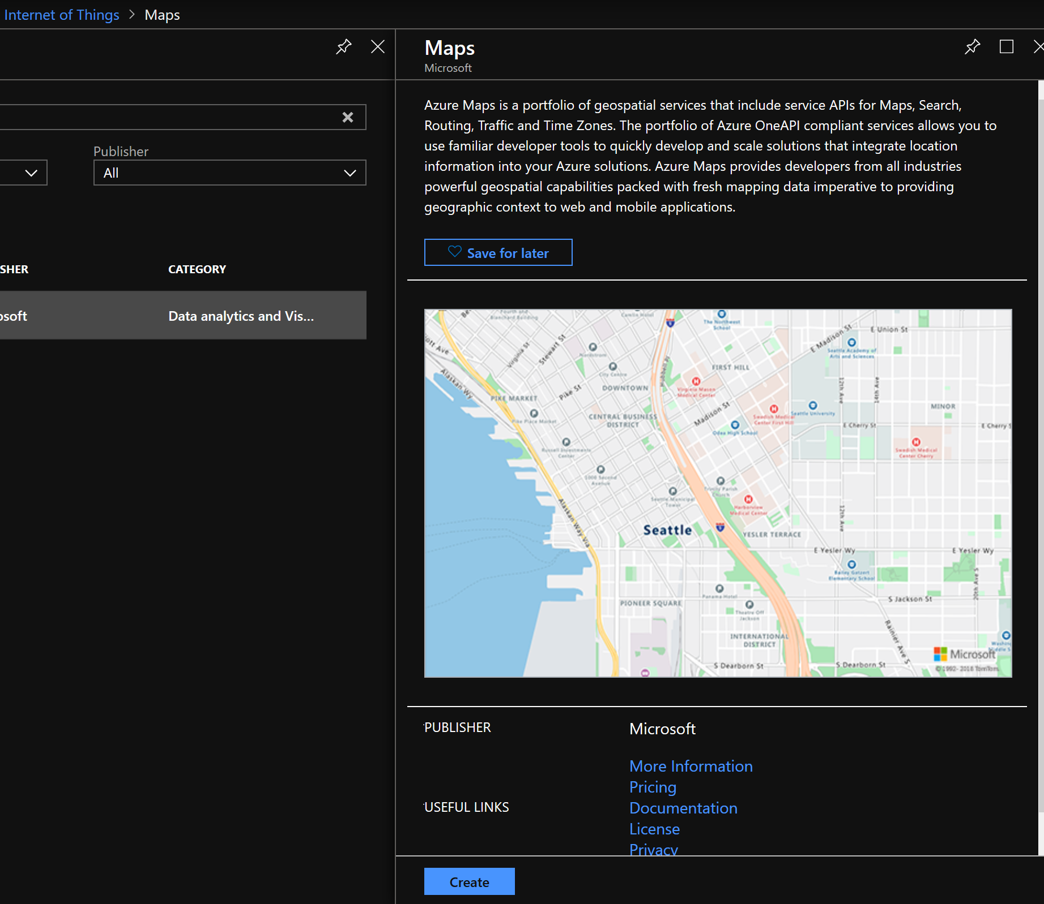

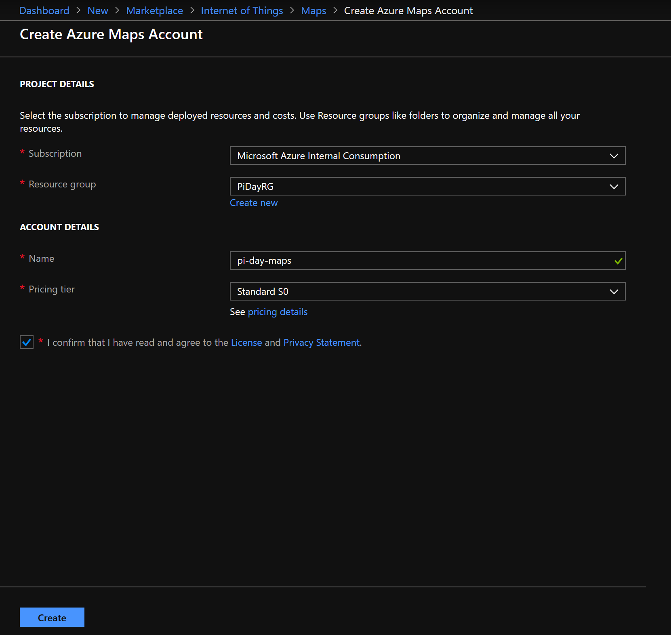

This is what your resource group should look like albeit with different names:

